Guide for Identifying Entanglement Material Commonly Found on
Steller and California Sea Lions in Southwest British Columbia

by
Wendy Szaniszlo, MSc.
Research Associate, Vancouver Aquarium
P.O. Box 3232, Vancouver, BC V6B 3X8

Table of Contents

Introduction 2
Materials Considered 2
Plastic Packing Band 2
Rubber Band 5
Corded Line/Thread 7
Gill Net 9
Monofilament Line 10
Identifying Entanglements 10
Active Entanglements Vs Scar 15
Active 15
Scar 16
Misidentification 16
Active - looks like a scar 16
Scar - looks active 17
Documentation Tips 18

Introduction
This guide will provide an overview of the most common materials found entangling sea lions in southern British Columbia and provide guidance in determining whether entanglements are active or are scars.

Materials Considered

Plastic Packing Band

Plastic packing bands are the most common material found entangling sea lions in southern British Columbia (Figures 1-5). The bands are thin, white, approximately one centimeter in width, and moderately flexible. Typically the bands are found in loops. Although the source of the plastic packing bands is not known, the most common use for them in marine environments is for securing bait boxes.

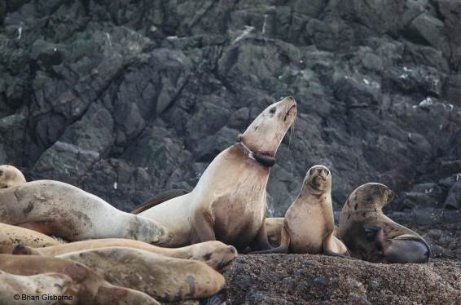

Figure 1: plastic packing band Note how the edges of the band can cut into the flesh causing a bulbous appearance.

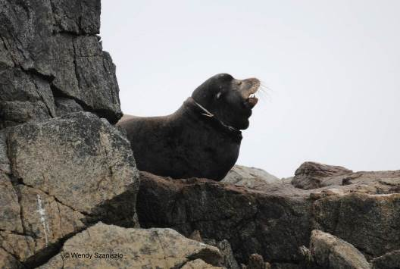

Figure 2: plastic packing band The packing band has a distinctive white, thin, flat appearance. It is common to see these bands fray.



Figure 3: plastic packing band It is common to see plastic packing bands on the necks of adult and subadult Steller and California sea lions.
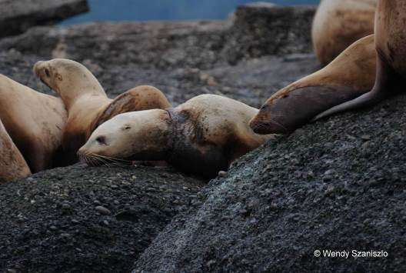

Figure 4: plastic packing band Note the thin, tiny fray on the dorsal side of the neck.

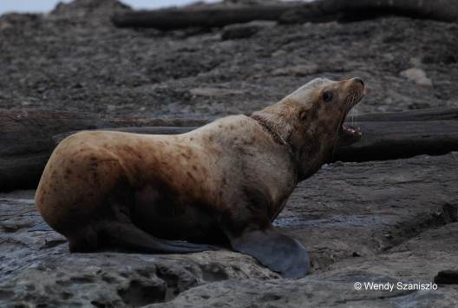

Figure 5: plastic packing band

Rubber Band

Crab pot rubber bands are used in conjunction with crab pot lid hooks and bait hooks to secure lids and bait jars to a crab pot. The rubber bands are black, approximately 2.5 cm wide and 10 cm long. These have only been seen on Steller sea lion pups and juveniles in southwestern BC.


Figure 6: rubber band

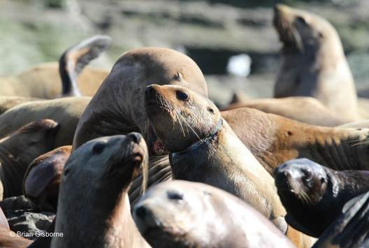

Figure 7: rubber band



Figure 8: rubber band

Corded Line/Thread

Tough cord/thread material was observed on several California sea lions along southeast Vancouver Island. Although the material was collected by Fisheries and Oceans Canada after disentanglement rescues, the material and its source remains inconclusive. The line is off-white in colour, less than half a centimeter in diameter, and appears to knot and tangle easily. Pieces removed from sea lions were at least a meter in length. Note in Figures 9-11 that this material causes entanglements lower on the neck and/or on the chest when compared to plastic packing band and rubber band entanglements.

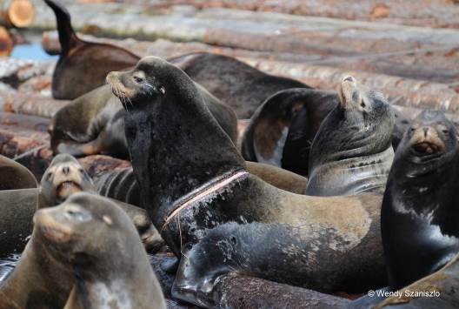

Figure 9: cord material

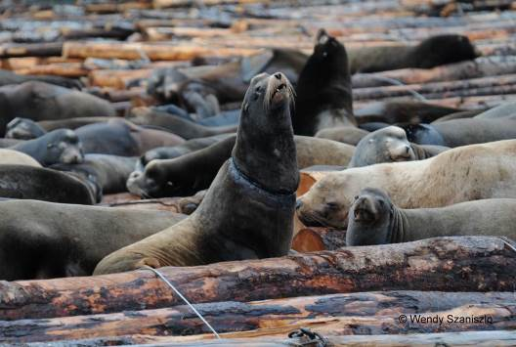

Figure 10: cord material

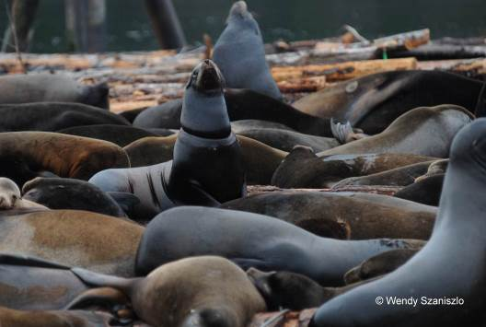

Figure 11: cord material

Gill Net

Given the sea lion-herring fishery interactions in the Strait of Georgia (southeastern Vancouver Island) this gear type is likely to pose an entanglement risk to sea lions.

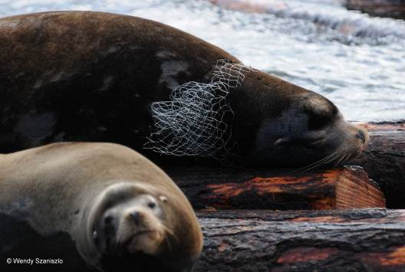

Figure 12: herring gillnet Mesh size and configuration may differ between Canada and the United States.

Monofilament Line

Monofilament line is fishing line made of a single fiber of plastic. Figure 13 illustrates a heavy monofilament line. Note the multiple long, clear strands.

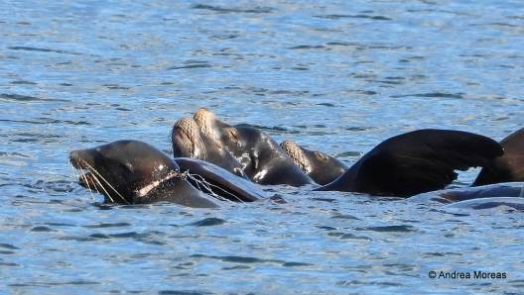

Figure 13: monofilament line

It is often not possible to confidently identify entanglement material since many times it cannot be seen. This is sometimes due to poor quality photos, but also in cases where the material is so deeply embedded that it cannot be seen.

Identifying Entanglements
Entanglement wounds can present from appearing inactive (such as a scar) to severe. ‘Severity’ is a subjective assessment of an entanglement and its resulting wound. Below are examples of entanglements with varying levels of severity. Characteristics of different entanglements are described. Severity is ranked on a scale of 0 to 5, with 0 being an entanglement scar and 5 being an entanglement in which the material is embedded deeply and heavy purulent discharge is present.

Figure 14: Severity 0 - scar; no entanglement material is present and the wound appears healed
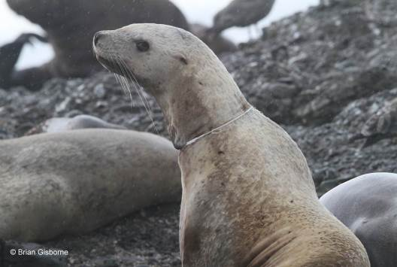
Figure 15: Severity 1 – entanglement material is present but it is loose; material does not cut into flesh
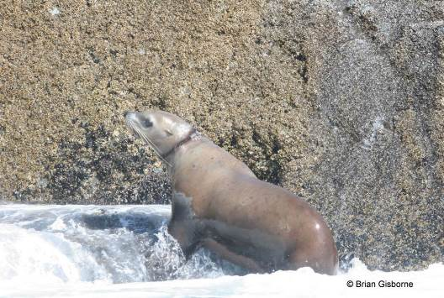
Figure 16: Severity 2 – entanglement material is present and is snug against the skin; material cuts slightly into the flesh; entanglement site may appear dark; wound might weep. In this example the material cannot be seen.
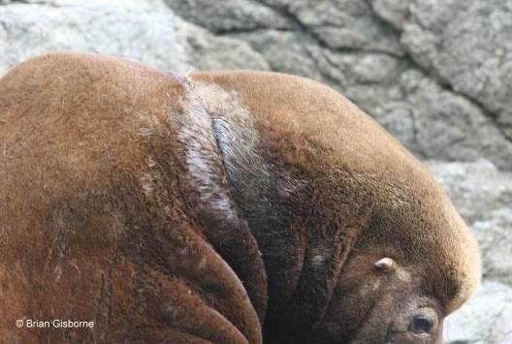
Plastic packing band fray
Figure 17: Severity 2 – entanglement material is present and is snug against the skin; material cuts slightly into the flesh; entanglement site is weeping.
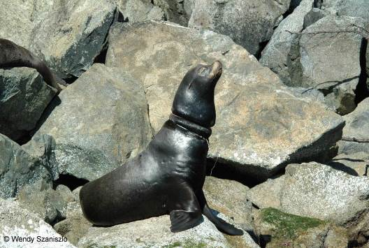
edema
Figure 18: Severity 3 – entanglement material has broken the skin and has ‘cinched’ around the neck creating an indent; edema is present; purulent discharge may be present
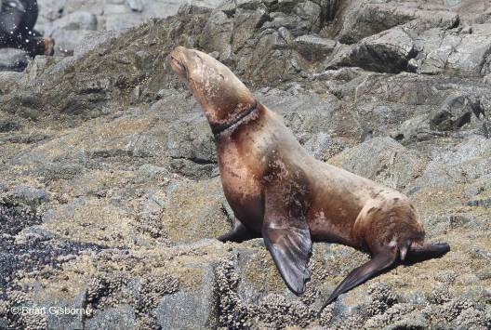
Figure 19: Severity 3 – entanglement material has broken the skin; edema is present; purulent discharge may be present
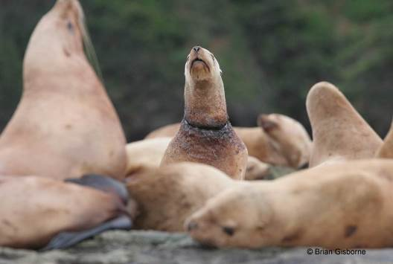
Figure 20: Severity 4 – entanglement material is embedded and may not be seen; the entanglement site appears tightly cinched; significant edema and/or purulent discharge is present
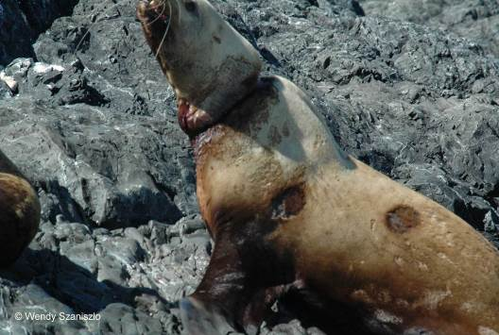
Figure 21: Severity 5 – entanglement material is deeply embedded and cannot be seen; edema is present; there is purulent discharge and blood at the wound site; the wound appears ‘meaty’; the entanglement appears to be life threatening (interfering with feeding, breathing and or/movement)

Active Entanglements Vs Scar
While there are some defining characteristics of an entanglement it is not always possible to confidently confirm an active entanglement by observation or photos alone. The primary characteristics of an active entanglement and a scar are outlined below, followed by two examples of ‘misidentification’ to demonstrate caution when interpreting entanglement characteristics.

Active
An entanglement can be assumed to be active if the 1) entanglement material is present and/or 2) the wound caused by the entanglement is severe enough to present with one or more of the following: discolouration, weeping, edema, purulent discharge, blood, ‘meatiness’ (pink flesh is visible) (Figure 22).


Figure 22: Active entanglement based on wound characteristics. Note the deep indentation, discolouration, weeping and presence of pink flesh on the ventral side of the neck.

Scar
Entanglement scars may present as active entanglements. A defining feature of scars is the absence of entanglement material, and more specifically, the obvious absence of material at the entanglement site where no scar exists. The scarred area may appear dark and scarred (Figure 23).

no material or cinching
no material visible and no obvious edema or weeping
Figure 23: Scar Note the absence of entanglement material, particularly on the ventral side of the neck. There is no material or any cinching, discolouration, weeping or any other sign of an entanglement.

Misidentification
From sea lion disentanglement rescues conducted with the Vancouver Aquarium’s Marine Mammal Rescue Center staff it has been found that what appears as a scar may in fact be an active entanglement, and an active entanglement may be a scar. Below are examples of two sea lions which were assumed to be actively entangled and darted. Only one (Figure 24) was.

Active - looks like a scar
Upon close examination, the California sea lion shown in Figure 24 appeared to be scarred. The entanglement site was predominantly dry, had dark scar tissue, and no material was visible. When the site was palpitated, foreign material was felt below the skin. Small incisions revealed that scar tissue had grown over the plastic packing band.
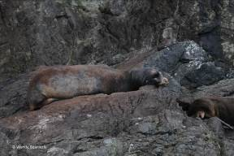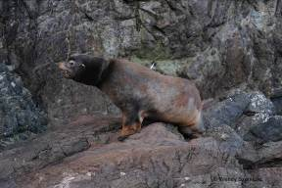
minimal cinching
No material visible, no weeping, and tissue appears scarred
Figure 24: Active entanglement presenting as a scar

Scar - looks active
Upon close examination, the Steller sea lion illustrated in Figure 25 did not have an active entanglement. Although the wound site had the ‘cinched’ appearance of an entanglement, when the animal was sedated and the entanglement site was examined there was no material present. The wound was ‘fresh’ and pink exhibiting the ‘meatiness’ of a severe entanglement.

Figure 25: Scar presenting as an active entanglement

Documentation Tips
The amount of entanglement material visible can vary at any point on the neck (or other entanglement site). Therefore, to confirm whether entanglements are active and to increase the potential of observing the material it is recommended to photograph all angles of a sea lion’s neck. It is ideal, though rarely possible, to circumvent the animal and continuously take photos of the entanglement site (Figure 26) or take photos of the entangled animal from a variety of angles (Figure 27).
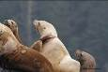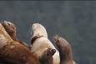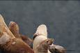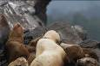

Figure 26: Ideal photo documentation of an entangled sea lion showing all angles of the entanglement site

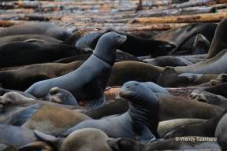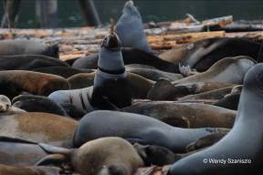
Cord/thread
Figure 27: Photo documentation of an entangled sea lion showing two angles of the entanglement site. Note that the image on the right confirms an active entanglement and allows for confirmation of entanglement material.

